**MobileApp workflow for Feedback Provider**

**First Screen after you click on app, Wait till the screen change to next screen**

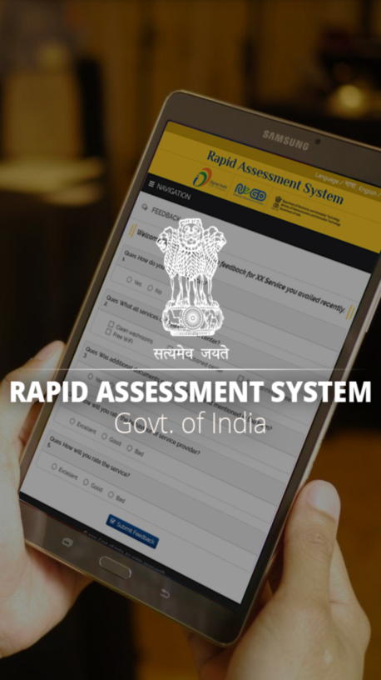

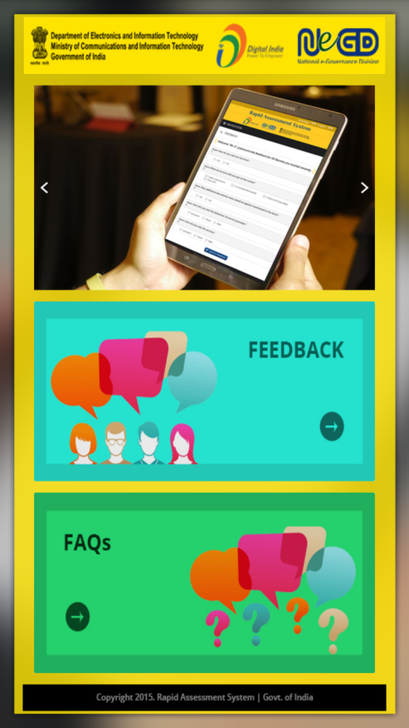

**Click on Feedback Icon.**

**If there is no connection then this screen will appear.**

**Click on Refresh button to check internet connection.**

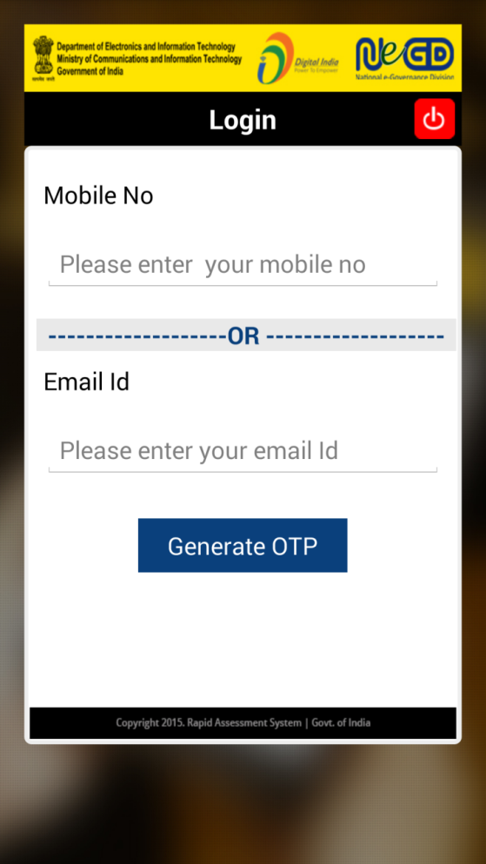

**Please enter your mobile number.**

**OR**

**Please enter your email id.**

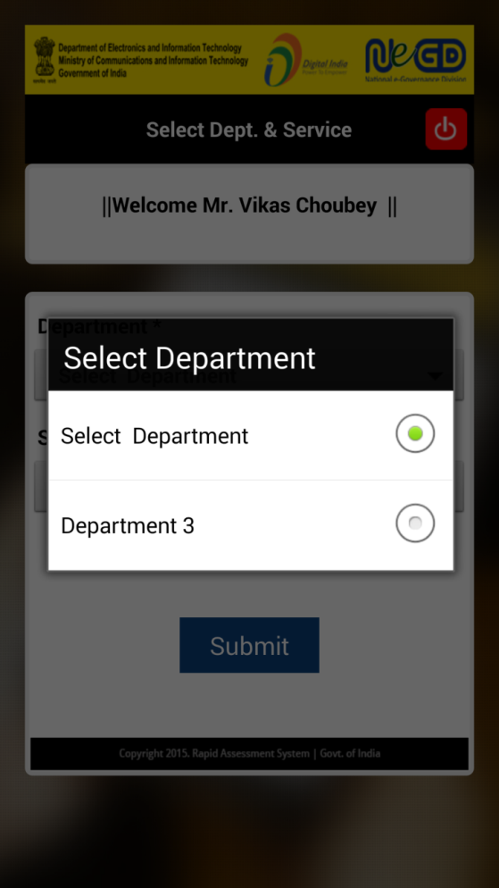

List of department.

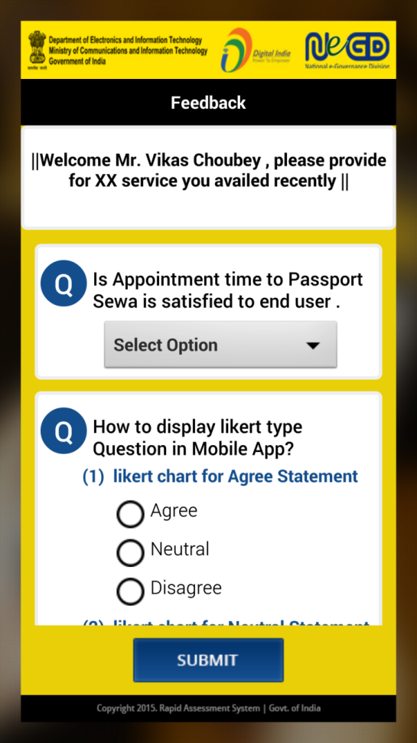

**List of drop down and likert type question.**

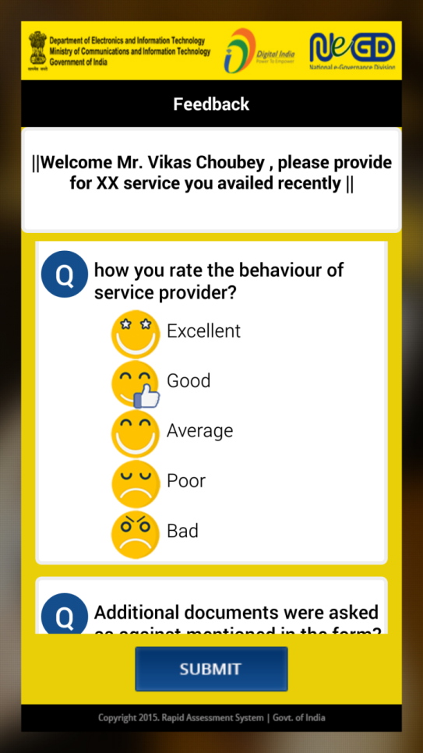

**Pictorial type question.**

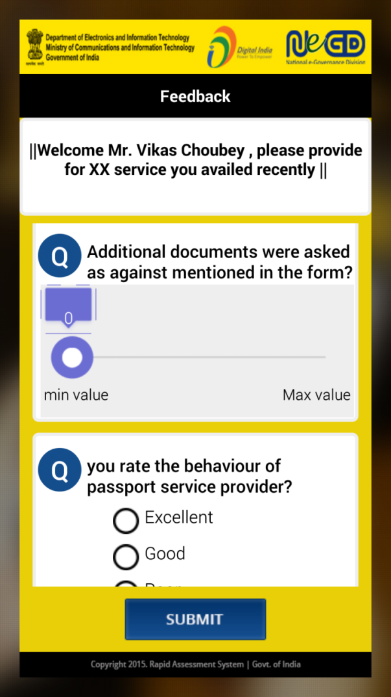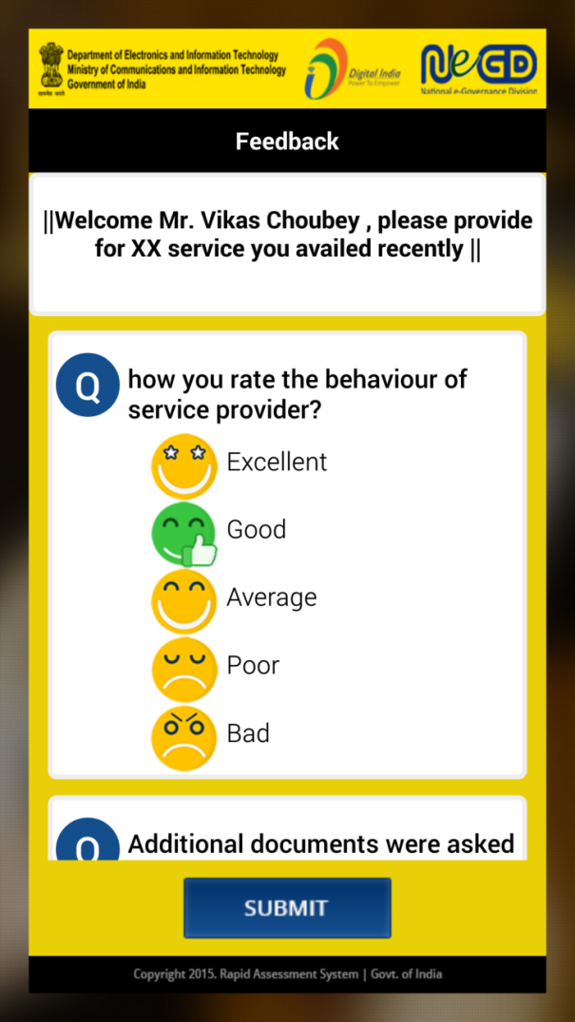

**Graphical type question.**

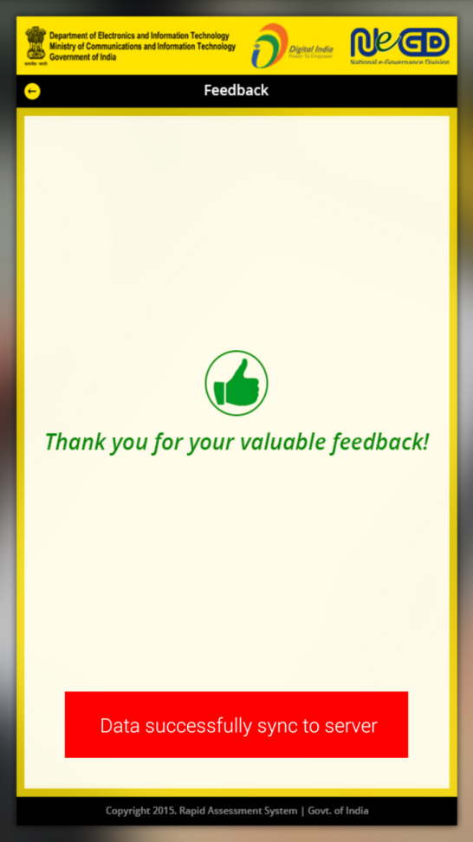

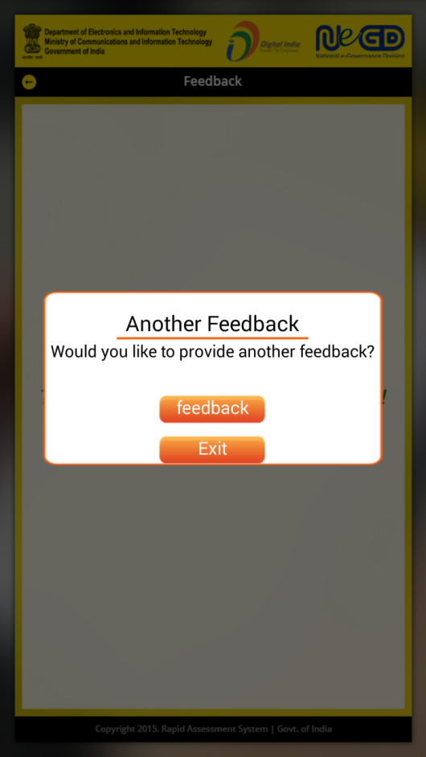

**If you want to give more feedback on different services associated with different department, click on Feedback Icon.**